Activity: 5 Ways to Wellbeing
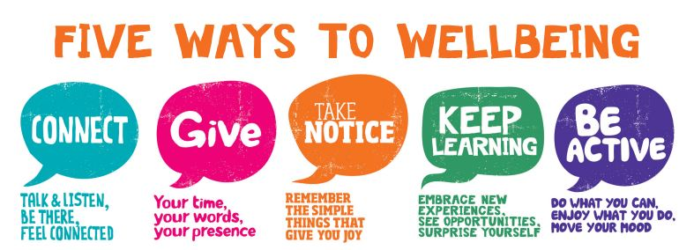

The UK government’s futures think-tank the Foresight Project - ‘Mental Capital and Wellbeing’ chaired by Dame Carol Black - commissioned over 400 experts in psychology, psychiatry, neuroscience, education, and economics from across the world to review current knowledge on mental health and well-being.
The New Economics Foundation (nef) was asked to take the key findings and develop them into a set of evidence based actions that could be easily adopted by people within their daily lives.
These actions, formulated by the nef as ‘5 Ways to Wellbeing’ are also now used by various Government departments (in the UK, New Zealand and Canada) to inform government, social and corporate strategy to increase levels of flourishing within the community and the workplace.

Find out more below
http://neweconomics.org/2008/10/five-ways-to-wellbeing-the-postcards/?_sf_s=ways+to+wellbeing

Look at the activities below and tick the things you are already doing in each area.
Rate yourself then commit to action in at least one area.

Connect | What do I already do?  - Eat lunch with others  - Attend afternoon teas, social drinks or staff interest groups  - De-brief with colleagues when feeling stressed  - Check in with others during times of increased stress or change  - Take time each day to be with family or friends  - Arrange outings with friends you haven't seen for a while  - Switch off the TV and play a game with the children/friends, or just talk  - Make the effort to phone people  - Take time to speak to new people  - Skype or FaceTime to stay in touch with friends and family  - Other ___________________________________________________________
Connect | How would I rate myself? 1 2 3 4 5
Connect | My plan to connect more is:
Be active | What do I already do?  - Exercise moderately 3 times a week for 30 – 60 minutes each time  - Walking meetings  - When stressed take a short walk outside  - Walk over and talk to a colleague in person rather than phone or email  - Organise a sporting match or tournament at work  - Take the stairs rather than the lift  - Cycle or walk to work  - Other ___________________________________________________________
Be active | How would I rate myself? 1 2 3 4 5
Be active | My plan to be more active is:

Take notice | What do I already do?  - Try not to dwell on what just happened or plan excessively for what’s coming up  - Focus on the here and now  - Focus on your breathing, sounds or sensations to ground yourself in the moment  - Use apps to learn/practice mindfulness e.g. smiling mind  - Have a regular time to practice mindfulness e.g. journey to work or a walk at lunchtime  - Try new things, sit in a different seat in meetings or go somewhere new for lunch  - Yoga, meditation, tai-chi  - Other ___________________________________________________________
Take notice | How would I rate myself? 1 2 3 4 5
Take notice | My plan to take notice more is:
Keep learning | What do I already do?  - Take on a new role or responsibility at work  - Develop new interests  - Take a class or a course  - Learn to cook a favourite dish  - Visit a gallery or museum and learn about a person or time in history that interests you  - Set yourself a DIY project (there are lots of free video tutorials online)  - Other ___________________________________________________________
Keep learning | How would I rate myself? 1 2 3 4 5
Keep learning | My plan to keep learning is:
Give | What do I already do?  - Join a community group or volunteer  - Give gifts of time, do small acts of kindness, help others  - Notice when colleagues do good things  - Encourage a culture where everyone’s contribution is recognised and valued  - Join national campaigns and work with colleagues to fundraise and contribute  - Say thank you to someone, for something they’ve done for you  - Phone a relative or friend who needs support or company  - Ask a colleague how they are and really listen to the answer  - Sign up to a mentoring project  - Other ___________________________________________________________
Give | How would I rate myself? 1 2 3 4 5
Give | My plan to give more is:

Activity: Wellbeing Action Plan
As a group, select 2 activities from the 5 ways to wellbeing that you would like to implement in your team, work location or organisation.
Plan how you can implement these activities.

Activity 1:
Expected benefits:
Steps to implement:
Resources required:
Who can perform these tasks:
Who owns this implementation:
Anticipated completion:

Activity 2:
Expected benefits:
Steps to implement:
Resources required:
Who can perform these tasks:
Who owns this implementation:
Anticipated completion:

Key message
There are simple things we can incorporate into our ________________________ that can help build our resilience in the 5 key areas of wellbeing;
- _____________________
- _____________________
- _____________________
- _____________________
- _____________________
These actions can help to promote and protect your mental health and wellbeing.

Other Items I can focus on:

